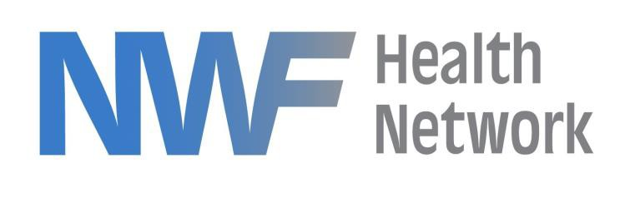

April 18, 2023

To whom it may concern,

NWF Health Network has begun Phase 2 of the re-procurement of Circuit 1 contracted services as required by contract with the Department of Children and Families. Phase 2 includes the following services:

• Foster Home Recruitment, Licensing, Training, and Support
• Behavioral Foster Home Program

We anticipate posting the RFP in mid to late July, 2023. The conclusion of Phase 2 is anticipated to occur with an award in August, 2023 with effective date of the contracts on or about October 1, 2023.

Subsequent phases of the re-procurement of services will be released at a future date.

Jeffrey A. Pic
Procurement Manager, NWF Health Network

525 N. MARTIN LUTHER KING BOULEVARD, TALLAHASSEE, FLORIDA 32301
WWW.NWFHEALTH.ORG

