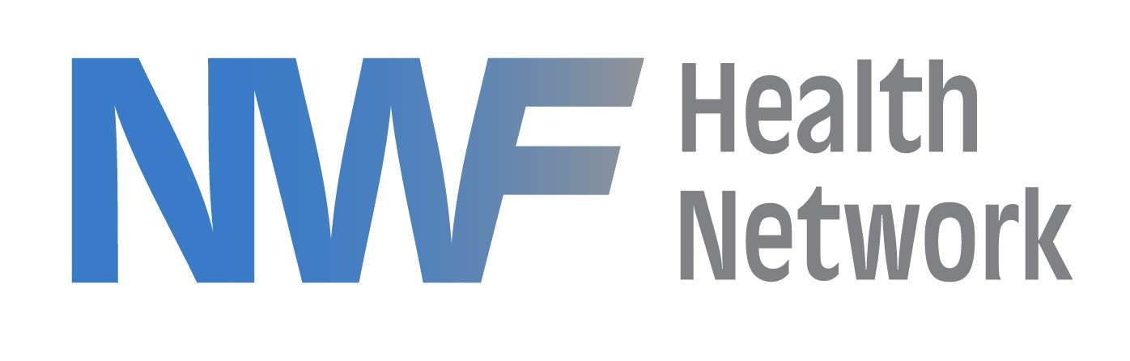
POSITION TITLE: Adoption Specialist

POSITION OBJECTIVE: This Position requires a high level of expertise in the area of the child welfare dependency process as related to obtaining permanency for the children in the State of Florida Child Welfare System..

ESSENTIAL FUNCTIONS MAY INCLUDE:
- Maintain a good working relationship with the Case Management Organizations (CMO’s), Adoptions, Children Legal Services (CLS) Department of Children and Families (DCF), Guardian Ad Litem Program (GAL) and Agency for Persons with Disabilities (APD).
- Provide support to the adoption unit in all aspects of program growth specifically through strategic and operation planning as it relates to permanency for children.
- Provide assistance to adoption units to improve case work practice and the administrative processes involved in service delivery.
- Participate in Adoption Enhance Subsidy staffings as needed.
- Identify service needs to help better facilitate a seamless, timely and efficient flow throughout the adoption process for children and families serve.
- Attend dependency court proceedings as needed to monitor the adoption performance as it relates to achieving permanency.
- Participate in the Adoption Applicant Review Committee (AARC). Review AARC packets from the Adoption Unit, provide support and training to help move AARC cases to permanency. Completes AARC reports, provides expert testimony related to 120 hearing filed and enters all documentation into FSFN.
- Compile performance reports as it relates to children who are free for adoptions and or have a goal of adoptions.
- Participate with all system partners establishing the annual adoption goal.
- Participate in permanency staffing as needed as well as chairing special staffings related to APD clients, permanency or complaints.
- Maintain a list of all children who qualify for APD services as well as oversee new ADP applications for children
- Act as an APD liaison between DCF, CMO’s and NWFHN Placement. Work with APD
- Facilitate the Behavioral Health Discharging Planning calls; working with the Placement Manager to ensure Champions are assigned to children who meet the qualification.
This list of essential functions is not intended to be exhaustive. NWFHN reserve the right to revise this job description as needed to comply with actual job requirements.

QUALIFICATIONS:
REQUIRED:

- A Bachelor’s degree from an accredited university

- A minimum of 5 years of experience in child welfare services to include Case Management and Adoptions.

- A thorough knowledge of the Florida Safe Families Network (FSFN) management system.

- Child Protection Professional Certification-Prior certification and significant employment history in the child welfare field may substitute.

PREFERRED:

- Previous experience working with APD
- Knowledge of FSFN
- Supervisory experience
- Knowledge of Florida Statue/Administrative Code that governs child welfare

SKILLS:

- Strong verbal and written communication
- Ability to act with a high level of independent judgment
- Strong working knowledge of law and rule
- Ability to research as a means to problem solve, develop policy/processes
- Knowledge of professional ethics relating to child protection and counseling
- Ability to handle confidential information appropriately
- Ability to set appropriate limits and boundaries with clients

POSITION SUPERVISES: N/A

I have read and understand this job description and hereby certify that I am qualified to perform this job, with or without a reasonable accommodation.

________________________________ ____________________________________
Name (Print) Supervisor’s Name (Print)

________________________________ ________________________________
Employee’s Signature Supervisor’s Signature

____________________________ _________________________________
Date Date

