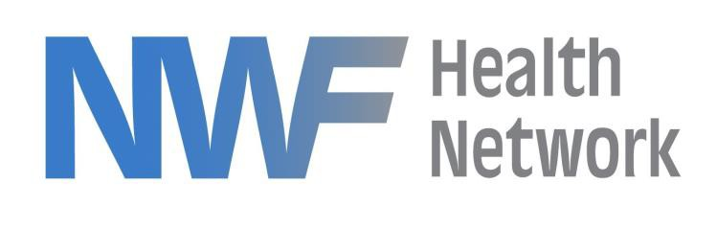

September 5, 2023

This notice serves to inform interested parties that NWF Health Network intends to award the contract for Post-Adoption Services in Circuit 1 to Children’s Home Society of Florida. The decision to award the contract is based on a thorough evaluation of the submitted proposals, during which Children’s Home Society of Florida demonstrated a strong alignment with the project's requirements and objectives.

We extend our congratulations to Children’s Home Society of Florida for their successful proposal submission and express our anticipation for a fruitful partnership. We believe that their expertise and dedication will greatly contribute to the project's success.

Jeffrey A. Pic

Procurement Manager

Jeffrey A. Pic

Procurement Manager, NWF Health Network

***525 N. MARTIN LUTHER KING BOULEVARD, TALLAHASSEE, FLORIDA 32301***

[***WWW.NWFHEALTH.ORG***](http://WWW.NWFHEALTH.ORG/)